They will need to add WAN to LAN access rules as shown to the firewall. To this they would need to first setup address objects also shown below.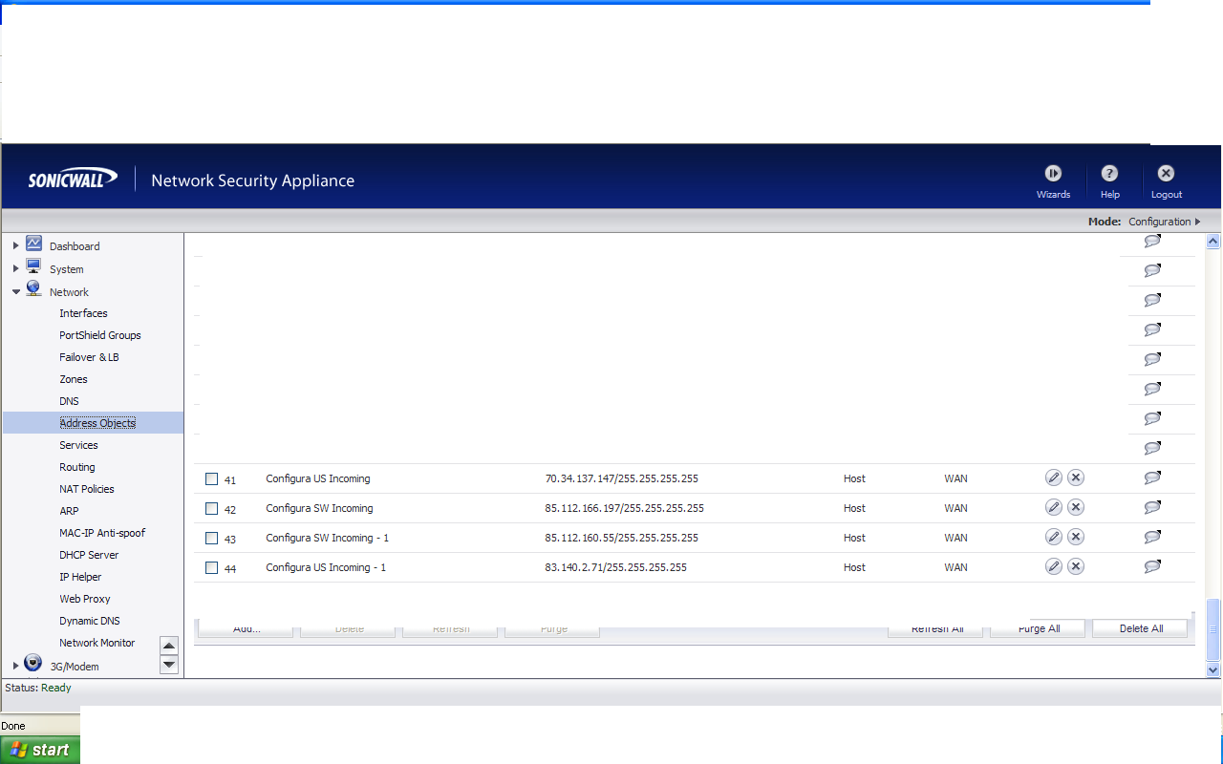
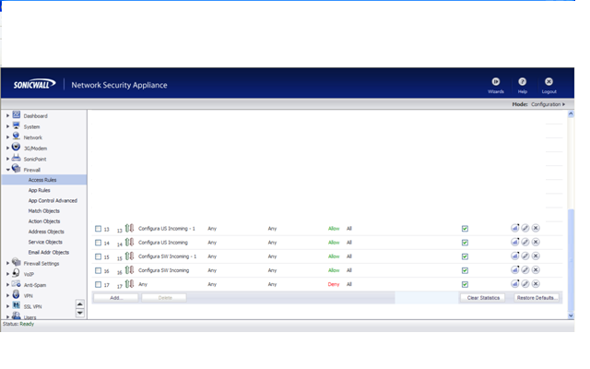
In addition they need to add the following exclusions:

To the Gateway Anti-Virus under Security Settings.
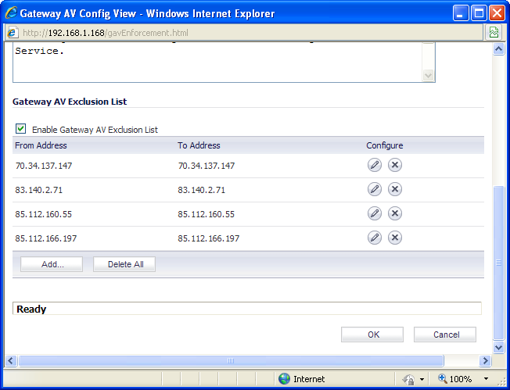

To the Intrusion Prevention under Security Settings
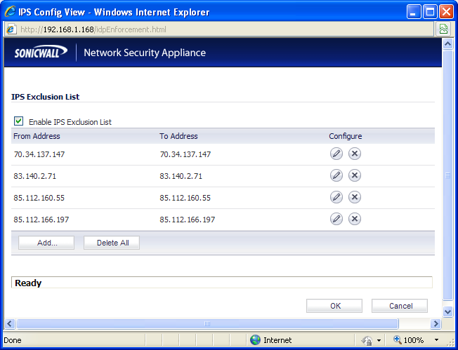

And also to Anti-Spyware under Security Services
